**CD Project: AI Based Compiler for Object Detection using YOLO Approach**

Performance Parameters

1. Prediction Examples  
   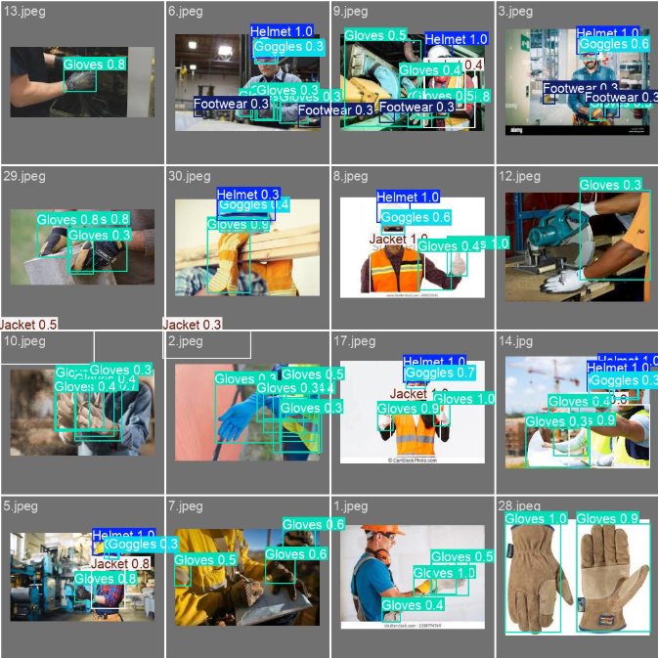
2. This graph shows the model's training and validation loss, precision, and recall over epochs. Notice how the loss stabilizes and the metrics improve steadily after optimizer-based hyperparameter tuning, confirming better generalization and quicker convergence.

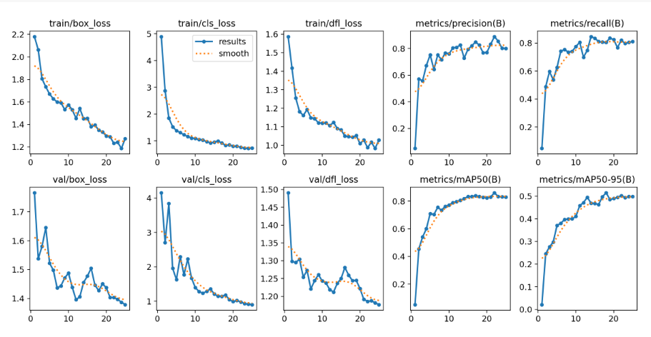

1. This confusion matrix visualizes the model’s classification performance on the test dataset. Each row represents the actual class, and each column represents the predicted class. The high values along the diagonal indicate strong detection performance for multiple PPE categories like Helmet, Gloves, and Footwear.

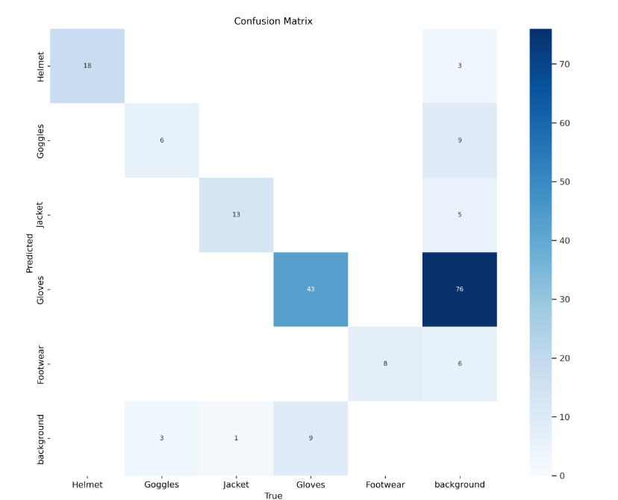

1. This output shows the best hyperparameters selected by the PSO-GWO hybrid optimizer. These parameters led to the highest mAP50 score of 0.7478 and were used in the final YOLOv8 training run to achieve optimal results.

